**TOOLS AND TECHNOLOGIES USED**

In the development of the "Encryption and Decryption of Text Using Caesar Cipher" software, several tools and technologies were utilized to ensure a robust and user-friendly application. The primary tools and technologies used are as follows:

1. **Python**
   * **Description:** Python is a high-level, interpreted programming language known for its simplicity and readability. It is widely used in various domains, including web development, data analysis, artificial intelligence, and cybersecurity.
   * **Usage in Project:** Python was the core programming language used to implement the Caesar Cipher encryption and decryption functions. Its extensive standard library and supportive community made it an ideal choice for this project.
2. **Streamlit**
   * **Description:** Streamlit is an open-source app framework for Machine Learning and Data Science projects. It allows developers to create interactive and visually appealing web applications quickly and easily.
   * **Usage in Project:** Streamlit was used to develop the user interface of the software. It facilitated the creation of an intuitive and interactive interface where users could input text, select shift values, and choose to encrypt or decrypt the text. Streamlit's simplicity and effectiveness in building web applications made it a suitable choice for this project.
3. **Streamlit Cloud**
   * **Description:** Streamlit Cloud is a platform that allows developers to deploy and share their Streamlit applications easily on the cloud.
   * **Usage in Project:** Streamlit Cloud was used to deploy the application, making it accessible to users via the web. This ensured that the application could be easily shared and used without the need for local installations.
4. **Git**
   * **Description:** Git is a distributed version control system that tracks changes in source code during software development. It helps manage project versions and collaborates with team members efficiently.
   * **Usage in Project:** Git was used for version control throughout the development process. It allowed for systematic tracking of changes, facilitated collaboration, and ensured that the project could be rolled back to previous versions if necessary.
5. **GitHub**
   * **Description:** GitHub is a web-based platform that uses Git for version control. It provides a collaborative environment for developers to share and work on projects together.
   * **Usage in Project:** The project repository was hosted on GitHub, enabling seamless collaboration, code review, and project management. It also served as a backup for the codebase and documentation.
6. **PyCharm**
   * **Description:** PyCharm is an integrated development environment (IDE) for Python developed by JetBrains. It provides code analysis, a graphical debugger, an integrated unit tester, integration with version control systems, and supports web development with Django.
   * **Usage in Project:** PyCharm was the primary code editor used during the development of the project. Its powerful features, such as intelligent code completion, code inspections, and integrated debugging tools, significantly enhanced productivity and code quality.

**IMPLEMENTATION**

import time  
import streamlit as st  
import streamlit.components.v1 as components  
def Caesar_Cipher(inp,val):  
 enstr = ""  
 for i in inp:  
 if 'A' <= i <= 'Z':  
 enstr += chr(((ord(i) - ord('A') + val) % 26) + ord('A'))  
 elif 'a' <= i <= 'z':  
 enstr += chr(((ord(i) - ord('a') + val) % 26) + ord('a'))  
 else:  
 enstr += i  
 return enstr  
def User_Interface(str1, str2):  
 with st.spinner(text="Please Wait", cache=True):  
 time.sleep(2)  
 with st.status(f"{str1} data"):  
 time.sleep(2)  
 st.write(f"{str2} done")  
 pg = st.progress(0)  
 for i in range(101):  
 pg.progress(i)  
 time.sleep(0.01)  
 st.success(f"{str2} done :smiley:")  
flag=0  
components.html('''<style> body{padding:20px;}</style><body bgcolor = "powderblue"><h1><center><b>Caesar Cipher</h1></body>''')  
st1 = st.file_uploader("Click here to upload file",type="txt")  
if st1 is not None:  
 f_open = st1.read()  
 f_open = f_open.decode('utf-8')  
 inp = f_open  
if st1 is None:  
 st.markdown("### OR")  
 st.subheader("Enter the text")  
 inp = st.text_input("Text")  
opt = st.selectbox("Select the operation",("Encrypt","Decrypt"))  
  
if opt == "Decrypt":  
 val1= st.selectbox("Choose the value to decrypt",(-1,-2,-3,-4,-5))  
 btn = st.button("Click to decrypt")  
 if btn == True:  
 flag = 1  
elif opt== "Encrypt":  
 val = st.selectbox("Choose the Value to Encrypt",(1,2,3,4,5))  
 btn = st.button("Click to Encrypt")  
 if btn == True:  
 flag =2  
if flag== 2:  
 User_Interface("Encrypting","Encryption")  
 res = Caesar_Cipher(inp,val)  
 st.code(res)  
 st.download_button(label="Download Encrypted File :open_file_folder:",data=res,file_name="Encrypted.txt", help="Click to download")  
elif flag==1:  
 User_Interface("Decrypting","Decryption")  
 res = Caesar_Cipher(inp,val1)  
 st.code(res)  
 st.download_button(label="Download Decrypted File :open_file_folder:", data=res, file_name="Decrypted.txt",help="Click to download")

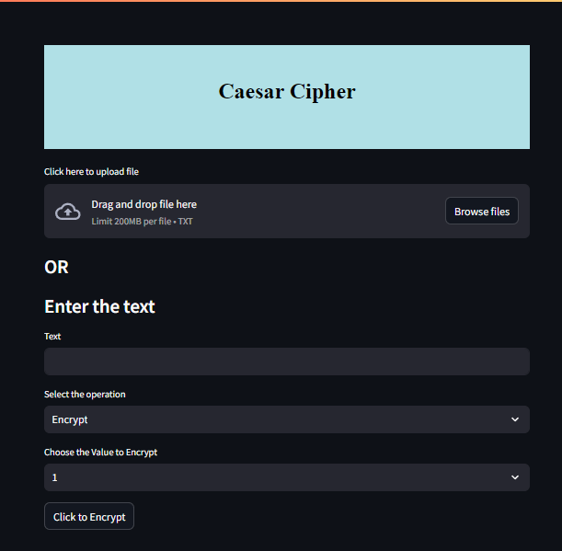

URL - https://text-encryptor-decryptor.streamlit.app

**OUTCOME OF THE INTERNSHIP**

The internship at Exposys Data Labs was an enriching experience that provided significant practical learning in cybersecurity and software development. The primary objective of developing a software application for the encryption and decryption of text using the Caesar Cipher was successfully achieved. The application, built with Streamlit and Python, includes a user-friendly interface that allows users to input or upload text, select a shift value, and perform encryption or decryption. The functionality to download or copy the processed text further enhanced the user experience.

Throughout the internship, I gained valuable technical skills, including improved proficiency in Python, hands-on experience with Streamlit, and knowledge of version control using Git and GitHub. Additionally, deploying the application on Streamlit Cloud provided insights into cloud computing. This experience also improved my problem-solving and debugging abilities, as well as my documentation and communication skills. Overall, the internship offered a comprehensive understanding of working in a professional environment, effectively managing project requirements, and collaborating with experienced professionals.

**CONCLUSION**

The internship at Exposys Data Labs has been a valuable and transformative experience, providing me with both technical skills and professional insights. The primary project, focused on developing a software application for the encryption and decryption of text using the Caesar Cipher, was successfully completed. This project allowed me to delve deeply into the fields of cryptography and software development, using tools such as Python and Streamlit to create an effective and user-friendly solution.

Through this internship, I have enhanced my programming skills, gained experience in web development, and learned the importance of thorough testing and documentation. Deploying the application on Streamlit Cloud further expanded my understanding of cloud computing and deployment practices. The guidance and support from my mentor, Mr. Aravind Kumar R, and the team at Exposys Data Labs were instrumental in my growth and development during this period.

Overall, this internship has solidified my interest in cybersecurity and software development, providing a strong foundation for my future career. The skills and knowledge I have acquired will undoubtedly contribute to my continued success in the field. I am grateful for the opportunity and look forward to applying these learnings in future projects and professional endeavors.